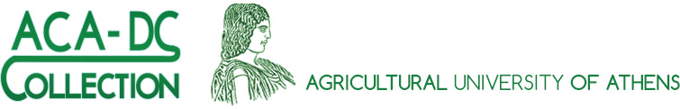

IDENTIFICATION SERVICE

ACA-DC Culture Collection  Laboratory of Dairy Research  Agricultural University of Athens  75 Iera Odos, 11855 Athens, Greece  Phone: +30 210 529 4644 / 4628 / 4661  Fax: +30 210 5294672  Email: mae@aua.gr; gz@aua.gr; et@aua.gr  Website: www.aca-dc.gr | For ACA-DC use only  Customer number:  Date of receipt:  Strain 1 ID No.  Strain 2 ID No.  Strain 3 ID No.  Strain 4 ID No.

Strain data
No. | Designation of the isolate | Source of the isolate | Provided isolate type
Strain 1
Strain 2
Strain 3
Strain 4

Cultivation of the strain(s)
 | Strain 1 | Strain 2 | Strain 3 | Strain 4
Medium (attach formula
if necessary)
Incubation temperature (ºC)
Incubation time
Oxygen requirements | 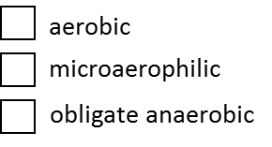 | 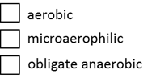
Other growth requirements (special gas, light, etc.)
Risk group of the strain known?  If yes | 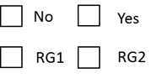

Additional strain information [It would be useful if you provide us with any already existing identification data for the under identification strain(s)]

Identification cost | Unit price (Euro)
Strain 1
Strain 2
Strain 3
Strain 4
 |  | Total price (Euro)

Customer specific information
Customer number:
Contact person:
Organization/Company/Laboratory:
Address:
Telephone number:
Fax number:
E-mail address:

Invoice information:
Contact person:
Organization/Company/Laboratory:
Invoice address:

VAT number (EU Member States only):

Date………………………… Signature of the supplier…………………………………………………

REMARKS

- If you do not have a customer number, your order will be handled as a "first order". Your first order should be sent by e-mail, written on paper with the customer's official letterhead, signed by an authorized person. With your first delivery, a customer number will be allocated to your organization/company/laboratory.

- ACA-DC accepts for identification services only bacterial strains up to biohazard group 2 as mentioned in the directive 2000/54/EC or its updates.
- The basic requirement to start the identification work is the purity of the isolate(s) under identification.
- Cultures will be retained for a reasonable length of time after which they will be destroyed.

- Identification cost per strain is 200 Euros
- A broad range of methods is available for the strain identification at the genus or species level by the ACA-DC Culture Collection including:
- Phenotypic systems, e.g. API strips
- Genotypic techniques, e.g. partial 16S rDNA sequencing
- DNA fingerprinting techniques, e.g. PCR amplification of repetitive bacterial DNA elements (rep-PCR) and pulsed-field gel electrophoresis (PFGE) are applied to discriminate bacterial cultures at strain level

- Please fill out the form and send it by e-mail to one of the addresses below:
mae@aua.gr (Eugenia Manolopoulou, MSc, Curator)
gz@aua.gr (Georgia Zoumpopoulou, PhD, Staff Member)
et@aua.gr (Effie Tsakalidou, Professor, Director)
- Please send the filled form by e-mail earlier than the biological material
- The pre-announcement for the delivery of the biological material will be appreciated
- Regarding packaging and mailing pay attention to the national transport regulations

